September’s Istanbul
The new season has kickstarted by the end of bayram. As the rays of sun lower their angles, the climate is perfect and as of september, İstanbul galleries have started opening up with some great shows. There is a storm of openings and events. September will be full of joy and music with many venues like Babylon and Salon starting off their programs along with the festivals. So here's a preview...

CONCERT

• Hercules & Love Affair – Sep 17, 2011 @ 23:00
Musical project from New York based DJ Andy Butler had made a great success with their first single “blind”.
Otto–SantralIstanbul, Silahtarağa Mah, Kazım Karabekir Caddesi 1, Eyüp.
• Yanni - Sep 18, 2011 @ 20:00
Greek self thought pianist, keyboardist and composer Yanni is one of the most popular performers of “new age” music.
Sortie, Muallim Naci Caddesi 54, Ortaköy, Kuruçeşme.
• Enrico Macias - Sep 13, 2011 @ 21:00
Algerian French Pied noir singer and musician is popular throughout the world and has travelled extensively for fifty years, from the early 1960s to the present.
Cemil Topuzlu Open Air Theatre, Taşkışla Caddesi, Harbiye. (0212) 232 86 03
• Midnight Express: Mulatu Astatke – Sep 21-22, 2011 @ 21:30
Babylon, Şehbender Sok 3, Asmalımescit, Tünel. (0212) 292 73 68

WORKSHOP
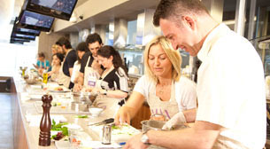
• Workshops in the Kithchen - Sep 07 - Sep 29, 2011
Cheesecakes - Sep 07, 2011
Meat Cooking Technics - Sep 10, 2011
8 Weeks in the Kitchen – Sep 11, 2011
Mixology with Laurent Greco - Sep 13, 2011
Cocktail Time - Sep 18, 2011
Pastery - Sep 21, 2011
Tapas - Sep 22, 2011
Sushi - Sep 24, 2011
Chief’s Menu: Various Tastes with Erkan Yeşil - Sep 29, 2011
MSA, Culinary Arts Academy, Meydan Sokaka, Beybi Giz Plaza B Blok 123-136, Maslak. (0212) 290 35 50.

FESTIVAL
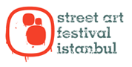
• Street Art Festival - Sep 2011
(annual)Paintings, graffiti, music and the performing arts enliven the streets of Istanbul for three days during the Street Art Festival. Free to both artists and visitors, the initiative supports cultural exchange through the arts. www.streetartistanbul.com
• 5th International Istanbul Poetry Festival Sep 13 - 17 2011
One of the biggest international literary events in Turkey. Held in annually in Istanbul, the event invites some 40 authors from Europe, Africa and beyond, giving visitors a broad overview of poetry in present times.
Beyoğlu Cultural Center for the Youth, French Cultural Center, Italian Cultural Center, Muammer Karaca Theatre, Mephisto Bookstore, Tarık Zafer Tunaya Cultural Center.
• Uni-Rock - Sep 9 - 11 2011
An annual open-air heavy metal festival, attracting 40,000 party goers. Camp on site and enjoy three full days of quality live music. Eluveitie from Switzerland, Hammerfall from Sweden and Mayhem from Norway...
Küçükçiftlik Park, Kadırgalar Caddesi 5, Maçka
• Istanbul Design Week - Sep 29 - Oct 2 2011 (annual)
Attracting businesses and individuals from all over the world, Istanbul Design Week at the old Galata Bridge provides a space to unleash creativity, compare ideas and pick up on new trends through a range of exhibits, shows and events.
The event, which is driven by a new theme every year, is held around the iconic landmark connecting the Asian and European sides of Istanbul. Exhibitions present sculptural pieces and design concepts, while workshops, lectures, parties awards and competitions run alongside the main event.
Galata Bridge.

FAIR
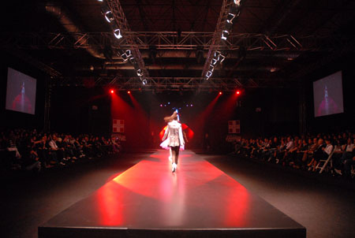
• International Istanbul Fashion Fair – Sep 22 – 24, 2011
Turkish ready-to-wear clothing industry is revealed at the biannual International fair. Turkish and international designers manufacturers, importers, global brands, retailers and department chains are all present.Visit the festival website for an online invitation form.
CNR Expo International Fair Center, Atatürk Havalimanı Karşısı D.T.M. Yeşilköy. (0212) 465 74 74
• Istanbul Houseware & Gift Fair - 23 - 27 Sep 2011 (annual)
The latest design trends from Eastern and Western markets. On offer is a plethora of gift ideas, from glassware, ceramics and leather goods to handwoven Assamese products.
Tüyap Exhibition Center, Beylikdüzü E-5 Highway beyond the airport, Gürpınar Kavşağı, Beylikdüzü. (0212) 219 39 39

EXHIBITION
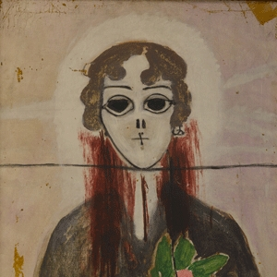
• Semiha Berksoy - 15 September 2011 - 25 October 2011
Versatile artist who was Turkey's first female opera artist as well as being a painter and a stage actress. Titled “Semiha Berksoy on the 101st Anniversary of Her Birth”, the exhibition will feature around 30 pieces of oil on canvas by Berksoy as well as videos of the artist.
The Çırağan Palace Kempinski Art Gallery, Çırağan Cad. No: 32 Beşiktaş.
• Augmented Structures V1.1: Acoustic Foormation - Sep 2011 - 30 Nov 2011
Refik Anadol is currently part-time instructor in İstanbul Bilgi University Visual Communication Design department. He is working in the fields of live video/audio performance and architetctural photography, particularly he is interested in the relationship between architecture and media.
Yapi Kredi Cultural Center, İstiklal Caddesi No:161 Beyoğlu. (0212) 2524700

